Dear _________________

You are invited to join _________ at a giant “Scalextric” party!

Date: __________________ Time: ___________

LOCATION:

Pit Stop Promotions 21a Ferndown Northwood Hills HA6 1PQ

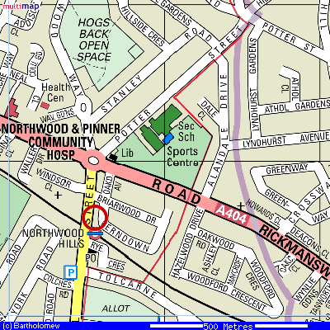
RSVP to ________________________________________
The track is situated in Northwood Hills close to the Metropolitan Line tube station. From the roundabout at the junction of the A404 and Joel Street, enter Joel Street and take the first left into Briarwood Drive and then after 25m take the first right into Ferndown.
From Eastcote head up Joel Street passing Northwood Hills tube on your right-hand side then take the first right into Briarwood Drive and then after 20m take the first right into Ferndown.

Once in Ferndown, we are situated approximately 50m down on the right, just before the road bears sharply round to the left. The drive and entrance are opposite the only telegraph pole in the road and are surrounded by a large security fence. Look for the 21a sign above the shutter! You will not be able to enter until 5 minutes before the start time. If you arrive early, please do not come in to the party in progress or bang on the closed shutter as we will know that you are there from our CCTV!

Please do not park across our neighbour's drives even for a few minutes and DO NOT park on the yellow lines when in force or with wheels on the kerb as YOU WILL get a ticket within minutes. Please park further down in Ferndown or Briarwood Drive or in the main road, Joel St.

For directions, please use Google Maps either on your smart device or PC and enter our post code HA6 1PQ
To see the track/venue please go to www.pitstoppromotions.co.uk

Some people find it difficult to locate us so please read carefully!

Please notify the party host if you are not coming or are going to arrive more than 15 minutes late as it affects the other guests and you will not be able to race once we have started.

If you have a Sat Nav, enter HA6 1PQ – the building number is 21a but if your unit does not recognise this then enter 21 instead. Our door is a roller shutter and is on ground level.

